timesten的安装step by step for RedHat AS5 64

因为工作的需要，我编写了一份timesten的安装文档。安装环境是RedHat AS5 64位的操作系统。

1、 用 root 登录系统

2、 在 /etc/sysctl.conf 文件后追加一些配置， vi /etc/sysctl.conf
#edit for timesten
net.ipv4.tcp_rmem=4096 4194304 4194304
net.ipv4.tcp_wmem=98304 4194304 4194304
net.ipv4.tcp_mem=98304 4194304 4194304
net.core.rmem_default=262144
net.core.wmem_default=262144
net.core.rmem_max=4194304
net.core.wmem_max=4194304
net.ipv4.tcp_window_scaling=1
net.ipv4.ip_local_port_range=1024 65000
kernel.sem=5000 32000 100 128
保存退出

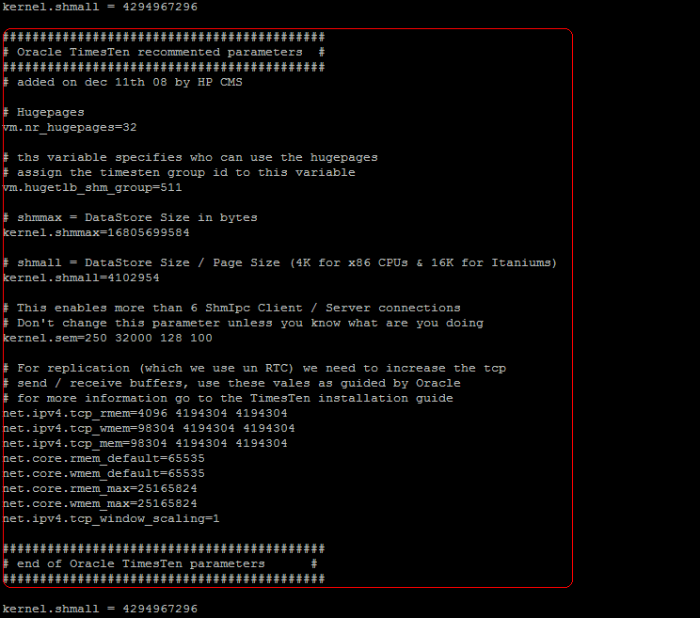

3、 修改 limit 配置
echo "* hard nofile 8192" >> /etc/security/limits.conf
echo "* soft nofile 8192" >> /etc/security/limits.conf
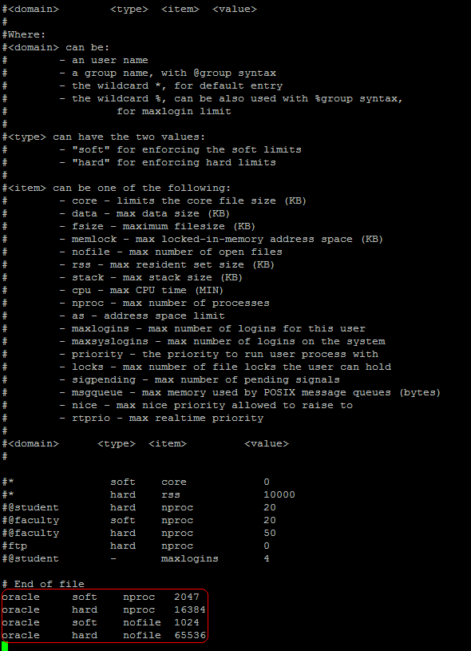
4、 重启机器
reboot

5、 建用户
useradd timesten -d /timesten

6、 用 passwd 命令修改 timesten 用户的口令为 timesten

7、 切换成 timesten 用户
su – timesten

8、 把 timesten112130.linux8664.tar.gz 放到 /timesten 目录下

9、 解压 timesten112130.linux8664.tar.gz
tar -xvf timesten112130.linux8664.tar.gz

10、 安装 timesten
su - root
mkdir /opt/TT/
chown timesten:timesten /opt/TT/
mkdir /etc/TimesTen
chown timesten:timesten /etc/TimesTen
chgrp -R timesten /etc/TimesTen

su – timesten
cd install
./setup.sh

11、 选择产品是 64 位，还是 32 位，出现如下提示：
Of the following two choices :

[1] 32-bit Linux for x86
[2] 64-bit Linux for AMD64 and Intel EM64T processors

Which platform are you currently running? [ 2 ]

选择安装 64 位 Linux 版本，确认回车

12、 确认 timesten 实例名，出现如下提示
NOTE: Each TimesTen installation is identified by a unique instance name.
The instance name must be a non-null alphanumeric string, not longer
than 255 characters.

Please choose an instance name for this installation? [ tt70 ]
默认选择 timesten 的 instance 名字，直接回车，提示：
Instance name will be 'tt70'.
Is this correct? [ yes ]
默认回车

13、 选择安装产品，出现如下提示
Please select a product :

[1] Oracle TimesTen In-Memory Database
[2] Oracle In-Memory Database Cache

Which product would you like to install? [ 1 ] 2
选择安装“ Oracle TimesTen In-Memory Database”，输入 2 ，确认回车

14、 选择安装组件，出现如下提示
Of the three components:

[1] Client/Server and Data Manager
[2] Data Manager Only
[3] Client Only

Which would you like to install? [ 1 ]
选择安装“ Client/Server and Data Manager ”，默认确认回车

15、 选择安装 timesten 的目录，出现如下提示
Where would you like to install the tt70 instance of TimesTen? [ /opt/TT/timesten ]
选择 /opt/TT/timesten，确认回车

16、 选择创建守护进程的主目录，出现如下提示
Where would you like to create the daemon home directory? [ /opt/TT/timesten /TimesTen/tt70/info ]
默认回车，出现如下提示：
The directory [ /opt/TT/timesten /TimesTen/tt70/info does not exist.
Do you want to create it? [ yes ]
提示目录不存在是否创建，默认选择 yes ，确认回车。开始解压安装，提示如下
Installing into /timesten/TimesTen/tt70 ...
Uncompressing ...

17、 解压结束后，安装 Demo 程序，出现如下提示
The TimesTen Demo applications can take up to 64 Mbytes of disk space.
Depending on how your system is configured, you may not want to create the
DemoDataStore directory in the default location,
/timesten/TimesTen/tt70/info/DemoDataStore

Where would you like to create the DemoDataStore directory? [/opt/TT/timesten /TimesTen/tt70/info ]
默认回车确认，提示如下：
Creating /opt/TT/timesten /TimesTen/tt70/info/DemoDataStore ...

18、 选择 timesten 守护进程的端口，出现如下提示
NOTE: All installations that replicate to each other must use the same daemon
port number that is set at installation time. The daemon port number can
be verified by running 'ttVersion'.

The default port number is 17001.

Do you want to use the default port number for the TimesTen daemon? [ yes ]
默认选择 17001 端口，确认端口没有被占用 [1] ，确认方法见脚注。
如果 17001 端口没有被占用的话，则默认回车确认，如果被占用，则输入 no ，回车，出现如下提示
Please enter a unique port number for the TimesTen daemon (<CR>=list)? [ ] 18011
输入一个没有被占用的端口，回车确认。系统提示安装过程：
Processing /timesten/TimesTen/tt70/PERL/perl.tar ...

19、 选择激活数据存储的控制权限，出现如下提示
Would you like to enable datastore access control? [ no ]yes
输入 yes ，回车确认，出现如下提示
The daemon log will be located in /timesten/TimesTen/tt70/info

20、 选择 timesten 守护进程日志
Would you like to specify a different location for the daemon log? [ no ]yes
为方便管理，应该重新选择日志目录，输入 yes ，出现如下提示：
Where would you like the daemon log to be written? [ /timesten/TimesTen/tt70/info ]

在新的终端 [2] 里面，用 timesten 用户登录，建立目录
cd /timesten/TimesTen/tt70
mkdir log

回到安装 timesten 的终端，输入新的目录
Where would you like the daemon log to be written? [ /timesten/TimesTen/tt70/info ] /timesten/TimesTen/tt70/log
回车确认，出现提示：
Are you sure you want the daemon log to be written to /timesten/TimesTen/tt70/log? [ yes ]
默认回车，确认把日志写到新建的目录下

21、 输入 ORACLE_HOME ，出现如下提示
NOTE: Cache Connect to Oracle requires the ORACLE_HOME environment variable.
If you cannot provide a valid path to your Oracle installation,
you must modify the script :
/timesten/TimesTen/tt70/bin/ttThunk
as well as the daemon options file :
/timesten/TimesTen/tt70/info/ttendaemon.options
when you have acquired the appropriate value.
Cache Connect to Oracle will not function properly without
ORACLE_HOME defined in these files.
Note that you can add or change this instance's ORACLE_HOME setting
by running <install_dir>/bin/ttmodinstall -changeOracleSetting.

Would you like to specify a value for ORACLE_HOME ? [ yes ]

默认回车确认，出现提示
Please enter a value for ORACLE_HOME (q=quit)? [ ]
因为安装 billing 应用的时候，已经把 oracle 的客户端安装好，所以这里直接输入“ /opt/oracle/product/10.2.0/db_1”
Please enter a value for ORACLE_HOME (q=quit)? [ ] /opt/oracle/product/10.2.0/db_1

回车确认，系统提示：
The following variables have been set in the file :
/timesten/TimesTen/tt70/bin/ttThunk

ORACLE_HOME= /opt/oracle/product/10.2.0/db_1

22、 激活 Cache Connect to Oracle Administrator ，出现提示
Would you like to enable the Cache Connect to Oracle Administrator? [ yes ]
默认回车确认

23、 选择 Cache Connect to Oracle Administrator 的端口，出现提示
What TCP/IP port number would you like Cache Connect to Oracle Administrator to listen on? [ 18005 ]
安装程序会提示一个默认端口，按照前面的方法确认这个端口没有被占用，如果占用则选择别的端口，输入正确的端口号，回车确认，出现提示
NOTE: To access the TimesTen Cache Connect to Oracle Administrator
go to the url: http://localhost:18005/cache

由于 g++ 版本的原因，安装程序可能会提示
NOTE: It appears that you are running version 4.1 of the g++
compiler. TimesTen ships with multiple sets of client libraries and server
binaries : one built with g++ 3.2.3, one with g++ 3.4.6, and one with
g++ 4.1.0. The installer has created links to the 4.1.0 library in the
<install_dir>/lib directory and to the 4.1.0 server binary in the
<install_dir>/bin directory. If you want to use a different compiler,
please modify the links to point to the desired library and server binary.

之后，系统开始安装 server 组件，安装程序提示
Installing server components ...

24、 选择记录所有 server 的连接和断开连接
Would you like to log all server Connects/Disconnects? [ yes ]
默认回车确认

25、 选择 TimesTen 服务 TCP 端口，出现提示
What is the TCP/IP port number that you want the TimesTen Server to listen on? [ 18003 ]
安装程序会提示一个默认端口，按照前面的方法确认这个端口没有被占用，如果占用则选择别的端口，输入正确的端口号，回车确认，出现提示
Starting the daemon ...
TimesTen Daemon startup OK.

Installing client components ...

26、 确认 TimesTen 服务安装的机器、端口、 instance ，出现提示
What is the name of the host running the TimesTen server? [ localhost ]
安装程序将获取本机的 hostname ，默认回车确认。

确认 TimesTen 服务的端口，出现提示
What is the TCP/IP port number that the TimesTen server is listening on? [ 18003 ]
此处安装程序将默认选择上一步的端口，默认回车确认

确认 TimesTen 服务的 instance ，出现提示
What is the name of the instance running the TimesTen server? [ tt70 ]
此处安装程序默认选择 tt70 ，默认回车确认

安装程序提示
Creating new /timesten/TimesTen/tt70/info/sys.ttconnect.ini
Extracting 3rd party tools ...

27、 不安装 TimesTen 文档，出现提示
Would you like to install the documentation? [ yes ]no
输入 no ，回车确认，出现提示
Documentation not installed.
To manually install the documentation, run the command 'setup.sh -installDoc'

28、 安装结束，安装程序提示如下
NOTE: The TimesTen daemon startup/shutdown scripts have not been installed.

As root, run the script 'set

linux useradd 命令详解
功能说明：建立用户帐号。
语 法：useradd [-mMnr][-c <备注>][-d <登入目录>][-e <有效期限>][-f <缓冲天数>][-g <群组>][-G <群组>][-s ][-u ][用户帐号] 或 useradd -D [-b][-e <有效期限>][-f <缓冲天数>][-g <群组>][-G <群组>][-s ]
补充说明：useradd可用来建立用户帐号。帐号建好之后，再用passwd设定帐号的密码．而可用userdel删除帐号。使用useradd指令所建立的帐号，实际上是保存在/etc/passwd文本文件中。
参 数：
-c<备注> 加上备注文字。备注文字会保存在passwd的备注栏位中。
-d<登入目录> 指定用户登入时的启始目录。
-D 变更预设值．
-e<有效期限> 指定帐号的有效期限。
-f<缓冲天数> 指定在密码过期后多少天即关闭该帐号。
-g<群组> 指定用户所属的群组。
-G<群组> 指定用户所属的附加群组。
-m 自动建立用户的登入目录。
-M 不要自动建立用户的登入目录。
-n 取消建立以用户名称为名的群组．
-r 建立系统帐号。
-s 指定用户登入后所使用的shell。
-u 指定用户ID。

